Government of Sindh, Pakistan

Sindh Water and Agriculture Transformation (SWAT) Project

Rehabilitation of Akram Wah Canal
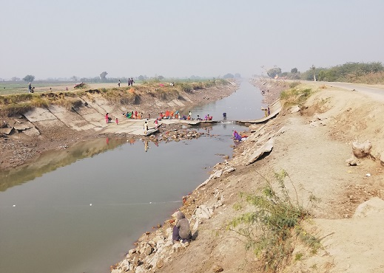

Environmental and Social Impact Assessment
Executive Summary

Sindh Irrigation and Drainage Authority (SIDA)
October 2022

The photograph on the cover page shows the poor condition of the current embankment of Akram Wah Canal.

Introduction
The Government of Sindh (GoS), through the Sindh Irrigation and Drainage Authority (SIDA), is planning to implement the Rehabilitation of Akram Wah Canal (the Subproject), with financial assistance from the World Bank, under the 'Sindh Water and Agriculture Transformation Project' (SWAT or the Project). The Akram Wah is a left bank canal of the Kotri barrage, located in the Sindh province. The Subproject will restore the irrigation flows (3,714 cusecs) of the canal by rehabilitating the existing embankment and concrete lining and replacing hydraulic structures. To address the environmental and social impacts of the Subproject, SIDA has prepared this Environmental and Social Impact Assessment (ESIA) in compliance with the national/provincial regulatory requirements and the World Bank's safeguard policies. A Social Management and Resettlement Plan (SMRP) has also been prepared for all resettlement impacts and anti-encroachment legacy issues of the Subproject and presented under separate covers.

Subproject Description
The total length of the Akram Wah Canal is 116 km or 382 RDs , and the location map is given in Figure E1. A schematic view of its sub canals and regulators are given in Figure E2. The proposed works in the Subproject include:
- Removal and disposal of existing damaged canal lining (59 km; RD 0 to RD 194)
- Construction of retaining wall through Hyderabad city (11 km; RD 0 to RD 36)
- Reprofiling of the earthen canal (48 km; RD 36 to RD 194)
- Embankment raising and strengthening (58 km; RD 194 to the tail end)
- Reinstatement of the Inspection Path (IP) and the Non-Inspection Path (NIP) for canal maintenance
- Replacement of 4 cross regulators, 13 head regulators and 1 escape structure
- Replacement of 8 syphons, existing sanctioned pump houses, 12 road and 6 footbridges, protection work to abutments, piers and deck slabs of existing pre-stressed concrete bridges
- Furnishing of Inspection bungalow and office at Badin, and construction of Engineer's office and staff quarters at Tando Muhammad Khan
In addition, the Subproject will build a temporary construction camp for workers at RD 48.5 and accommodate about 100 people and a few small temporary camps if needed by the Contractor to reduce the travel distance to the worksites. The camps will include batching plant, workshops, laboratory, Contractor's site offices and accommodation, labour accommodations, sanitation facilities, medical facilities, sewage disposal system and parking for vehicles and plant generators.
The proposed works will be carried out over 3 years, and most of the works will be carried out during the yearly canal-closure season to avoid the requirement of temporary diversion of canals.

Policy and Regulatory Framework
The Sindh Environmental Protection Act of 2014 is the primary legislative framework related to environmental protection in the province. In accordance with this Act, the rehabilitation of irrigation infrastructure will need to be approved by the Sindh Environmental Protection Agency (Sindh EPA) following the procedures given in the Sindh Environmental Protection Agency (Review of IEE and EIA) Regulations, 2014. These regulations classify the projects into two categories (Schedule I and Schedule II) for environmental clearances. The irrigation and drainage projects serving 15,000 hectares and above will fall under Schedule II (which requires EIA). The Subproject falls under Schedule II, and this ESIA will be submitted to Sindh EPA for obtaining the Environmental Approval for the Subproject.

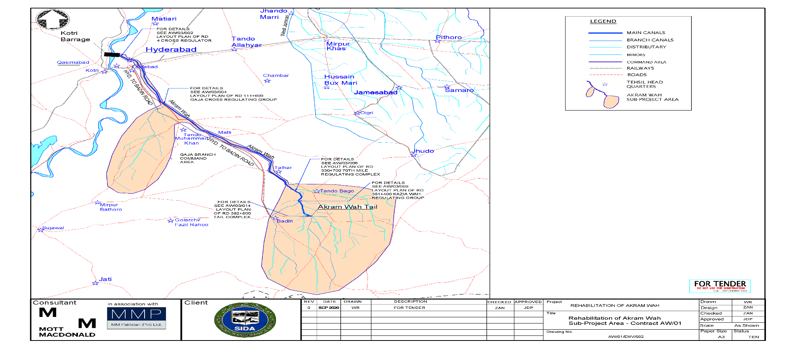
Figure E1: Akram Wah Subproject Area

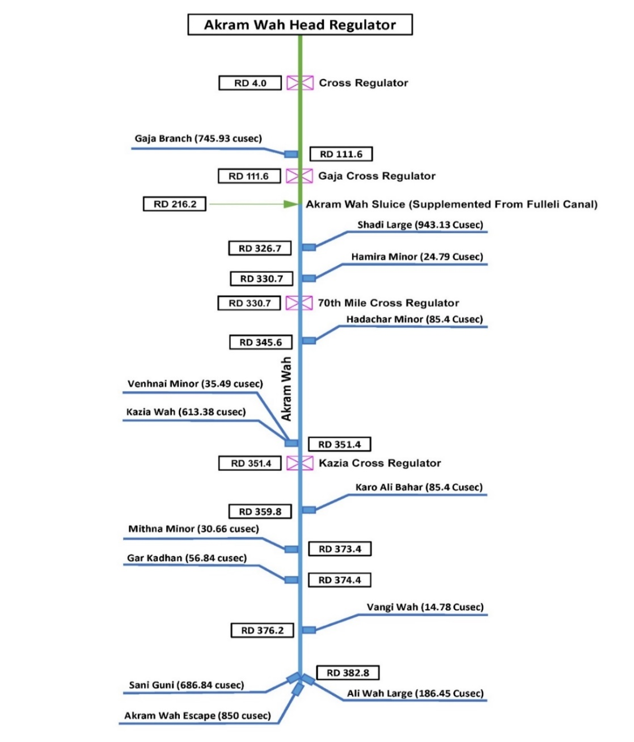
Figure E1: A Schematic View of Akram Wah’s Sub Canals

SWAT utilizes the World Bank Safeguard Policies, as opposed to the Bank’s newer Environmental and Social Framework (ESF), because the project entered the World Bank lending pipeline in late 2018, thus making it subjected to Safeguard Policies. According to World Bank's Operational Policy (OP) 4.01 (Environmental Assessment), the SWAT Project is classified as Category A. Other relevant World Bank policies applicable to the Project include Natural Habitats (OP 4.04), Physical Cultural Resources (OP 4.11), Involuntary Resettlement (OP/BP 4.12), Safety of Dams (OP/BP 4.37) and Projects on International Waterways (OP/BP 7.50). The Project's ESMF and this Subproject's ESIA have been prepared in compliance with these policies. Further, the stakeholder engagement plan (SEP) and labour management procedures (LMP), which are prepared in compliance with World Bank’s Environmental and Social Framework (ESF) and included ESMF, will also apply to the Akram Wah subproject.

Environmental and Social Baseline
Study Area. The study area (or the project area) primarily comprises of 116 km canal and its right of way (ROW), which is about 110 ft (34m) on each side from the centre of the canal. All the proposed rehabilitation works will be carried out well within the existing ROW (often less than 70 ft (21 m) from the centre of the canal, which is referred to as the Corridor of Impact or COI). The entire canal command area of the Akram Wah Canal is also considered under the study area. The Akram Wah canal passes through districts of Hyderabad, Tando Mohammad Khan and Badin.
Baseline Surveys. Detailed environmental, ecological, and socio-economic surveys were carried out in the project area through a secondary literature review, field investigations for primary data collection, sampling and analysis of water, air and noise quality, questionnaire surveys, and community and stakeholder consultations carried out during June 2020 to August 2021.

Physical Environment
Physical Setting and Land use: The canal mainly passes through the rural areas dominated by agricultural lands. Some sections pass through urban areas of Hyderabad (the first 11 km of the canal passes through Hyderabad city), Matli (District Badin) and Tando Muhammad Khan. Within urban areas, the RoW is heavily encroached upon by settlements. About 55% of the land use is agricultural land, 24% is settlements, 14% is shrubs, 6% is barren land, and 1% is orchards and plantation areas. The land use in the rural areas includes villages and smaller hamlets, housing areas, cattle farming, poultry farms, graveyards, shrines and houses/shops, fishponds, government dispensaries and police stations. The embankments are also dominated by trees and shrubs in some sections. The terrain is mostly flat. Beyond the RoW, agriculture is practiced on a larger scale, with cotton, wheat, rice and sugar cane being the dominant crops in the area. Cultivated areas are interrupted by large expanses of barren land. The agricultural land accounts for more than half of the land use within the subproject area.
Climate. According to Koeppen's climate classification, the Sindh area can be classified as a 'desert hot climate' because of its low annual rainfall compared to potential evapotranspiration and high temperatures. The summer season starts in April and ends in October (maximum temperatures reach up to 45 ºC), while the winter starts in November and ends in March (with the lowest temperature up to 3 ºC). The average annual rainfall in Hyderabad is 174 mm.
Geology. The project area is dominated by alluvial sediment deposits (with depths up to 90m), and hence the soils are generally suitable for agriculture. The groundwater is located in shallow depths and generally brackish, except near the canals. The groundwater is being used for drinking and irrigation at some locations.
Water Quality. In total, 12 water samples were collected from the project area; 8 of them are from Canal water and 4 from groundwater (2 from open wells and 2 from tube wells). The water quality parameters such as turbidity, pH, nitrate and biological contaminations exceeded the Sindh Environmental Quality Standards (SEQS) and WHO guidelines for drinking water.
Air and Noise Quality. Air and noise quality are measured at three villages in the project area. The ambient air quality in the project area is generally good and below the provincial environmental quality standards as the area has less exposure to industrial pollution. Vehicular traffic is a major source of both air and noise pollution. The particulate matter concentrations (PM₁₀) in the Fuleli area varies from 89 to 121 µg/m³ (the national standard is 150 µg/m³). The average daytime noise levels near the roads close to the canal's regulators vary from 59 to 61 dBA (the provincial standard is 55 dBA). The night time noise levels in the residential areas are generally less than the provincial standard of 45 dBA.

Biological Environment
Biodiversity. The biodiversity in the project area is mainly dominated by the vegetation and orchards on the embankments and seasonal water bodies mainly formed by the seepage of canal water. Several fishponds are also located along the right of way. The orchards include mango, jamon and lemon trees. The trees are dominated by Melia Indica (Neem), Albezia lebbeck (Sarehan), Phoenix dactlifera (Khajoor), Acacia Nilotica (Babur), Eucalyptus (Safaido), Zizyphus (Bair), Pithecellobium dulce (Jalebi), Ficus religiosa (Pipal), Pongamia pinnata (Sukhchain), Ziziphus jujube (Ber), Delonix regia (Gul Moher), Psidium guajava (Amrood), Melia Indica (Neem), Tamarindus indica (Imli), Conocorpus and Mangifera Indica (Amb). About 17 mammal and four reptile species are recorded during the field surveys. None of these species are listed under IUCN threatened species.

Socioeconomic Environment
Demography. The Akram Wah canal passes through 142 villages/goth in 7 tehsils of the three districts of Hyderabad, Tando Muhammad Khan and Badin. The socioeconomic baseline of the project area is collected through a survey of 291 households (27% of project-affected households) in all142 villages along the canal alignment and consultations with local communities. The population is primarily rural along the project alignment, except near Hyderabad. About 90% of the surveyed households are rural, and 10% are urban or semi-urban. The population of the surveyed households is 1999, in which 856 are male, and 1063 are female. The average family size of each household is about 7. About 51% of the surveyed households are classified as vulnerable people; households below the poverty line, female-headed households, and disabled people headed households.
Education. The literacy rate in the project area is very low compared to the national average. The level of illiteracy amongst men is 23.1% and 41.3% for women. About 8.3% of the surveyed population have access to boys' primary schools, 11.8% have access to girls' primary schools, 18.3% and 18.4% respectively have access to boys' and girls' middle schools, and 16.6% and 20.7% have access to boys' and girls' high schools.
Housing Conditions. About 6.2% of the surveyed households live in pacca houses (permanent structures made of brick and mortar). About 78% of households live in live semi-pacca houses (semi-permanent houses) made of cement, mud and bricks. Generally, families from lower-income households live in 'katcha’ houses made of mud, stones, wood, and or thatched shed.
Livelihoods and Household Incomes. Most of the affected households' primary livelihood sources (78.6%) are the daily wage labour in the farming sector, farming and livestock. Other main sources of income are businesses such as grocery stores and small eateries (7.9%), employment in government and private companies (3.8%). The surveyed households' average annual per capita income is PKR 24,634, whereas the average yearly household income is PKR 162,434. About 60 percent of this income is spent on food items (31 % of income) and other household expenses (29% of income) such as fuel, education, health, clothing, shoes, cosmetics, utility charges, and other miscellaneous expenditures.
Anti-Encroachment Drive. In early 2021, the Government of Sindh conducted a “anti-encroachment drive” (AED) throughout the entire on the orders of the Sindh High Court, including along the Akram Wah canal right of way. Approximately 1,246 household were affected, with more than 90% experiencing significant impacts. Most of the AED affected households were poor, informal settlers who were displaced from their homes. To address these legacy issues, SIDA prepared an Akram Wah Social Management and Resettlement Plan (SMRP) which will: i) provide an opportunity for AED affected households to improve their standard of living; and ii) pilot an approach to allowing AED affected households back on to the RoW in accordance with an Irrigation Department policy that was adopted in mid-2022.

Alternative Analysis
The current condition of the Akram Wah is very poor with the damaged embankment and canal linings and aged structures. Hence without works to replace and rehabilitate the infrastructure, the efficiency, reliability and equity of irrigation water distribution from this canal will continue to deteriorate. A number of options for rehabilitation were studied during the feasibility study, which includes the lining of canals only on areas where the seepage losses appear to be a real issue, the full lining of the canal, widening of the canal, and construction of retaining wall. Based on technical, economic, environmental and land acquisition criteria, a combination of these options has been adopted. The existing failed liner will be removed (currently extends RD 193.8). Retaining walls have been adopted through congested sections in Hyderabad, where additional land acquisition is not feasible. Downstream of Hyderabad, the canal will be reprofiled as an unlined earthen canal. Works from RD 193.8 to the tail will primarily consist of raising and strengthening canal embankments and berm formation where necessary.

Potential Environmental Impacts and Risks
The proposed Akram Wah canal rehabilitation works will be mainly carried out within the existing ROW. The most direct and significant adverse environmental impacts of the subproject will be on the natural landscape caused by the development of borrow areas, within the ROW, to source 22 million cubic feet (0.63 million m³) for the strengthening of the canal embankment and disposal of about 129 million cubic feet (3.6 million m³) spoils generated from the canal excavation, and acquisition of 9.6hectares (7.9 ha will be permanently for the minor realignment of off-taking canals and 1.7 ha will be temporarily for construction of temporary diversion channel). .
Adverse environmental impacts associated with the construction are mostly temporary and will mainly include waste generation, dust pollution, occupational health and safety risks and community exposure to work hazards. The overall positive impact of the Subproject, which is the restoration of irrigation, will directly benefit 187,000 hectares and 92,000 farming households in the command area by improving irrigation water supply efficiency and reliability in the command area. Renovating Akram Wah canal will benefit approximately 92,000 farming households by improving irrigation water supply reliability in the command area. Improvement in Akram Wah will also help ensure a reliable raw water supply for towns and cities that draw upon the canal, including Hyderabad, with a population of around 2 million. The Subproject’s potential impacts are given in the following table, along with significance (Critical, Major, Moderate or Minimal as per the criteria provided in Chapter 6) and the key mitigation measures.

Table 1. Potential Impacts of the Project and Key Mitigation Measures
The impact of various activities | Significance of Impact | Key Mitigation and Enhancement Measure
Environmental and Social impacts due to Project siting
1. Safeguarding the livelihoods of about 92,000 farming households in the Akram Wah canal command area through restoring irrigated water for 0.187 million hectares. | Critical beneficial | Subproject implementation
2. Loss of 6305 trees developed by the AWB and squatters in the footprints of the proposed works (594 trees between RD 4 and RD40; 2608 trees between RD 40 and RD195; and 3083 trees between RD 195 and RD382). These trees may be cut during the construction. | Major adverse | Tee cutting should be avoided to the extent feasible.  The Environmental Staff of the SIDA and construction supervision consultants (PIC) will review and approve each tree cutting by the Contractor.  A pre-construction survey will be carried out by the Environmental Staff of SIDA and the PIC to ensure no fauna and ecological features are affected  Contractor will prepare the inventory of all cut trees and will keep record of each cut trees by filling the chain of custody form, As per required details of chain of custody form proper handing and taking over will be ensured by getting the receiving signatures of concerned AWB officials to whom trees will be handed over. Concerned AWB would be responsible to auction all cut trees.  A compensatory tree plantation will be carried out within the ROW, adjacent to the canal embankments and embankment inspection roads, at the rate of 5 new trees for each tree cut with the same species. AWBs will maintain the trees ad replace the dead plants with new plants to ensure all new trees are survived.
3. The early 2021 Anti-Encroachment Drive (AED) impacted approximately 1236 households.  Permanent acquisition of 7.88 ha of private land outside of the RoW for minor realignment of off-taking canals. | Critical adverse | Implementation of the SMRP to compensate for lost assets, ensure stable and dignified housing, and support livelihood development.  Permanent land acquisition takes place per the RAP  .
4. Acquisition of 1.7 hectares of land temporarily to construct temporary canal diversion works prior to rehabilitation of canal cross regulators | Major adverse | Adequate compensation for affected households as per the entitlement matrix in the RAP  Restoration of the temporary diversions to the satisfaction of the landowners. This may include filling up the excavated channels with the borrow material or spoils generated by the canal excavation activities. If the landowner is willing to use the excavations to develop fishponds, the banks should be stabilized to prevent erosion and maintain a 2:1 slope.
Environmental impacts and risks during construction
5. A total of 129 million cubic feet or 3.6 million cubic meters of material will be excavated from RD 0 to the tail. Of this, 74 million cubic feet will be permanently disposed of within and close to the RoW. An additional 55 million cubic feet will need to be disposed of outside the RoW. | Major adverse | Spoil disposal sites have been identified and presented in the ESIA (Figure 3.6).  The Contractor can select the spoil disposal sites and submit the disposal plan for the Engineer's approval. The spoil disposal sites should be located in barren lands or government-owned lands. Minimize the requirement of developing spoil sites by planning borrow and spoil disposal activities so that borrow sites will be used for spoil disposal.  Transport and disposal of spoils at the designated disposal sites approved by the Engineer  Proper dumping and adequate compaction to avoid dust and release back to the canal or nearby agricultural lands.  Implement additional measures provided in ECPs 8 and 9
6. Borrowing 22 million cubic feet (0.63 million cubic meters) soil to construct the embankment. | Major adverse | Reuse of excavated material from the canal to the extent feasible to minimize the requirement of borrow material  About 30 borrow sites (covering an area of 22 hectares) have been identified within the ROW and presented in the ESIA (Figure 3.10). These areas are mainly located in the barren lands that are owned by the government and are not in agricultural use  The Contractor can select additional borrow sites and submit the plan for the Engineer's approval. The borrow sites should be located in barren lands or government-owned lands.  The excavations at the borrow sites, located within the ROW, should be limited to 2 ft to 5 ft to minimize the seepage of water from the canals.  Fill up the borrow areas with the spoil generated from the canal excavations. The banks of the borrow areas should be stabilized to prevent erosion and maintain a 2:1 slope.  Implement additional measures provided in ECP 9
7. Impact on downstream water releases during the rehabilitation of 9 cross regulators | Major adverse | The irrigation flows in the canal will be maintained by constructing and maintaining the temporary diversion channels and cofferdams around the hydraulic structures.  The rehabilitation of hydraulic structures will be scheduled in the low flow season or canal closure period (January to February).  Implement additional measures provided in ECP 19
8. Disruptions in the traffic due to reconstruction of 12 road bridges and 6 footbridges, and relocation of water pipelines | Major adverse | Preparation of traffic management plan by identifying the alternate routes to divert the traffic. Construct or rehabilitate the temporary diversion routes if required.  Relocation of utilities before the start of the construction activities.  Implement additional measures provided in ECP 15
9. Generation of construction waste, including 10.5 million cubic feet (0.30 million cubic meters) of canal lining consisting of concrete and bricks | Major adverse | Disposal of the construction waste in the designated spoil disposal areas or fill up the already developed borrow areas.  Implement additional measures provided in ECPs 1 and 2
10. Generation of solid waste from campsites and offices (about 50 kg per day), including hazardous waste | Major adverse | Implementation of the waste management plan  Segregation of solid waste into kitchen waste (organics), paper and plastic (recyclable) and garbage (non-recyclable). Placement of containers with adequate size and numbers.  Organic waste will be treated on-site using in-vessel composters, composting bins or composting pits.  Recyclable waste will be compressed through bailers and use services of the waste management contractor  Disposal of the garbage at the nearby municipal disposal areas  Containers of adequate size and numbers to collect hazardous wastes (used fuels, batteries, etc.)  Procurement of services of a waste management contractor for transport and treatment of recyclable and hazardous waste  Implement additional measures provided in ECP 1
11. Wastewater discharges (about 1,000 litres per day) from the construction camps, sites, and batching plants | Moderate adverse | Construction of wastewater treatment facilities at the campsite (e.g., septic tank and soak pit) and at the worksites (sedimentation tanks for batching plants and site drainage)  Monitoring of wastewater quality to ensure compliance with SEQS  Implement additional measures provided in ECP 3
12. The potential risk of soil and water pollution by construction works | Moderate adverse | Storage of fuels and chemicals in contained facilities  Availability of spill kits and trained personnel for immediate clean-up of any oil spills  Implement additional measures provided in ECP 2
13. Air and noise pollution from construction and traffic | Moderate adverse | Air and noise pollution control measures at the worksites and regular monitoring of ambient and noise quality to ensure compliance with SEQS  Compliance with SEQS on vehicle and machinery emissions  Implement additional measures provided in ECPs 10 and 11
14. Impacts from increased human activities on flora and fauna | Minimal adverse | Limit the siting of any temporary facilities within the boundaries of the worksites.  Use of non-wood fuel for cooking and heating  Code of conduct for workers and employees’ protection of flora and fauna and a ban on tree cutting and hunting. Any violation of code of conduct leads to strict punishment, including termination of employment  Implement additional measures provided in ECP 12, 13 and 14
Occupational Health and Safety Risks
15. Occupational health and safety risks on workers due to hazards associated with the construction activities (instream, drilling, working on heights and trenches, hot weather, etc.) | Moderate adverse | Develop and implement occupational health and safety plan in compliance with WB Environmental Health and Safety Guidelines.  Regular site inspections and safety audits  Regular training program for workers on occupational health safety (monthly training and daily toolbox talks)  Incident investigation and reporting  Conduct a ‘job hazard analysis’ at the new construction site to identify potential hazards and implement necessary control measures.  Use of relevant personal protection equipment at all times  Availability of firefighting, shelter during hot weather, first-aid and rescue facilities at the site  Adequate water supply and mobile toilets at the worksites  Take insurance policy for workers against potential injuries, both temporary and permanent (e.g., amputation of body parts such finger, hand, leg, foot et) and fatalities  Implement additional measures provided in ECP 18
16. Potential health risks due to inadequate facilities in the campsites (about 100 non-locals live-in construction camps) and spread of COVID-19. | Moderate adverse | A construction camp will be built with adequate facilities (safe drinking water and sanitation, kitchen, rest areas, recreation) for labor. Cleaning of all these facilities daily.  A medical clinic with a medical doctor and attendants, and preliminary staff will be established at the camp.  Covid -19 protocols will be followed at the construction sites and camps.  The Contractor shall establish a mechanism to collect the complaints from the workers and address those complaints by the approved GRM plan  Implement additional measures provided in ECP 20
Social Impacts and risks during construction
17. Safety hazards due to increased traffic on local roads, especially for children and elderly people | Major adverse | Implement a traffic management plan (e.g., avoiding school hours, following speed limits, hiring licensed drivers, etc.), including awareness-raising and safety measures.  Implement additional measures provided in ECP 8
18. Community exposure to work hazards | Major adverse | Barricade the work areas (near the settlements) with hard fencing to prevent the entry of community in the construction areas.  Placing adequate signboards and flagmen to divert the community away from the construction sites.  Community awareness programs on construction-related hazards, including awareness programs in schools  Implement additional measures provided in ECPs 16, 17 and 18
18. Employment generation for the local community | Major beneficial | The hiring of the local community during construction works (about 500 workers daily for three years)  Implement labour management procedures (LMP)  Implement additional measures provided in ECP 16
19. Labour risks during employment including risk of child labor | Minimal adverse | Implementation of LMP  Ensuring that children under 18 years of age are not employed directly or indirectly on the project.
20. Impacts from labour influx and potential cultural conflicts between communities and workers | Moderate adverse | The contractor’s code of conduct shall cover a program to promote awareness to the construction workers on respecting the local community.  Construction camps will be built in the designated areas, located away from the local settlements  The Contractor’s monthly training program will cover topics related to respectful attitude while interacting with the local community  Inclusion of code of conduct obligations and the applicable legislation in the contracts of all employees and workers with the provision of sanctions and penalties in case of violations  Implement additional measures provided in ECPs 16 and 17
21. Risk of gender-based violence (GBV), sexual exploitation and abuse (SEA), sexual harassment (SH), child abuse and exploitation. | Minimal adverse | The contractor’s code of conduct shall cover clauses related to avoiding gender-based violence, sexual exploitation and abuse, and sexual harassment. The code of conduct will be translated into Sindhi and disseminated.  The code of conduct will be included in the worker’s contract agreement, and any violation of the code of conduct will lead to termination of employment.  The contractor’s code of conduct shall cover a program to promote awareness to the construction workers on avoiding GBV, SEA, SH and the risk of spreading sexually transmitted diseases  The Contractor’s monthly training program will cover topics related to Code of Conduct such as sexual harassment, particularly towards women and children, violence, including sexual and/or gender-based violence  Measures to protect the privacy of women and girls by the contractor, sub-contractors and service providers
Chance-find procedures | Minimal adverse | Inclusion of chance find procedures given in Annex B in the bidding documents.
Environmental and Social impacts during Operational stage
1. Worker’s health and safety during routine operation and maintenance | Moderate adverse | Conduct a ‘job hazard analysis’ at the new operation/ maintenance sites to identify potential hazards and implement necessary control measures.  Use of relevant personal protection equipment at all times  Availability of firefighting, shelter during hot weather, first-aid and rescue facilities at the site
2. Community health and safety | Moderate adverse | Barricade the maintenance work areas (near the settlements) with hard fencing to prevent the entry of community in the construction areas.  Placing adequate signboards and flagmen to divert the community away from the maintenance works.

Environmental and Social Management Plan
Institutional Arrangements. SIDA has an Environmental Management Unit. The Environmental and Social Unit (EMU) of SIDA has existing environmental and social specialists (a deputy director, an environmental specialist, an ecologist, a sociologist, and 2 environmental inspectors). All these specialists have experience in the implementation of the World Bank funded Sindh Water Sector Improvement Project. The staff of EMU will be responsible for the overall supervision of the implementation of the ESMP. The Project Implementation Consultant (PIC) or Construction Supervision Consultant (CSC) will be responsible for supervising the contractors to implement ESMP. For this purpose, the PIC will appoint dedicated environmental, social, health and safety (ESHS) staff to ensure the implementation of ESMP. PIC staff will include an Environmental specialist, an Occupational Health and Safety Specialist, an Ecologist, Social Specialist, and ESHS site Inspectors. Contractors' ESHS staff include an Environmental Officer, an OHS Officer, a Community Liaison Officer, and ESHS Site Supervisors (one supervisor at each site).
Environmental Conditions in the Bidding Documents. To make the Contractors fully aware of the implications of the ESMP and responsible for ensuring compliance, technical specifications in the tender documents will include compliance with mitigation measures proposed in ESIA and World Bank Group EHSGs. The Contractor will be made accountable through contract documents for the obligations of implementing the ESMP.
Mitigation and Monitoring Measures. A mitigation and monitoring plan is developed and presented in the ESIA. An Environmental Code of Practices (ECPs) has been prepared (Appendix D) to address generic impacts associated with civil works. Prior to construction, the Contractor will prepare the Contractor's ESMP with site-specific management plans. The Contractor will prepare and implement a code of conduct for his workers. Regular trainings will be conducted to Contractor's workers on various ESHS aspects, including occupational health and safety, environmental protection, and awareness to the construction workers on avoiding gender-based violence.
Grievance Redress Mechanism. A project-specific grievance redress mechanism (GRM) will be established to receive, evaluate, and facilitate the resolution of affected parties' concerns, complaints, and grievances about the environmental and social performance. The first tier of GRM will be set up at the project level, which will constitute representatives of the SIDA, Contractor, and supervision consultant. The next level GRM will be established at the PMU level and will constitute the Project Director of PMU, Director AWB, Chairman AWB, Social Specialist of SIDA, Land Acquisition Collector, two Affected Person Representatives and five Canal Assistants of Akram Wah. The GRC will establish community complaints register at subproject sites. GRC will register and file all grievance redress cases and bring these to the notice of the Project Director. If the affected person is not satisfied with the decision of the grievance redress committee (GRC), they, as a lost resort, may submit the complaint to the court of Law.

Budget. The total cost of the ESMP implementation is estimated to be USD 0.83 million. It covers the implementation of measures proposed to hire staff for the contractors, implementing mitigation measures, environmental monitoring, tree plantation and capacity building activities. The cost estimates for implementation of the SMRP are not included in this amount and are provided in the SMRP itself.

Consultation and Disclosure
Extensive consultation and information dissemination (including with women) were carried out during ESIA preparation and disclosure. An initial scoping workshop was carried on 13th August 2020 to share the scope of the ESIA study with all the relevant stakeholders. A second workshop was carried out on 24th August 2021 to disclose the results of the ESIA. These workshops were participated by Area Water Board, Farmers Organizations, Sindh Environmental Protection Agency, Public Health and Engineering Department, Forest and Wildlife Department, Livestock and Fisheries Department, Irrigation Department, SIDA, Agriculture, Supply and Prices Department, and project implementation units of other World Bank and FAO projects in irrigation and agriculture sectors. Further, seven focus group discussions were conducted with the affected communities in the project area. Feedback from the consultations was overall supportive of the Project by all stakeholders. The general concerns of the local community, payment of compensation based on the market rates, employment in the construction activities, and adequate mechanism for grievance redress.
The ESIA and Executive Summary of ESIA were disclosed on the SIDA website in August 2021, and the revised versions, including the executive summary in Sindhi and Urdu, were disclosed in September 2022. The hard copies of these documents will be made available at AWB and FO offices for public access.
.

RD (Reduced Distance) is a measurement of canal chainage. Distance between each RD is 1000 ft

